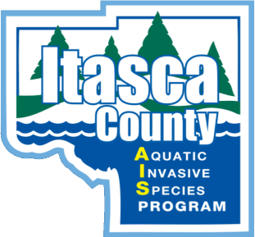

Equal Opportunity Employer
Itasca Soil and Water Conservation District Position Announcement
Position Title: Aquatic Invasive Species Control & Monitoring Technician
Position Status: Seasonal
Employment Duration: Mid-May through Mid-October (Flexible)
Starting Pay: $15.50 per hour
Hours: 8:00 AM to 4:30 PM Monday through Friday
Occasional weekends; not to exceed 40 hrs./wk.
Application Closing Date: April 14th, 2023
Position Summary:
The technicians will work alongside an experienced crew of Aquatic Invasive Species Control & Monitoring Specialists surveying lakes, rivers, and wetlands within Itasca County for all aquatic invasive plants and animals. This position will be almost entirely outdoors in all types of weather.
This position involves assisting in creating and implementing management plans for the control and monitoring of aquatic invasive species populations. Training will be provided in all areas of the program including the application of, and licensing for the use of herbicides.

Minimum Qualifications:
- Applicants must have a valid driver’s license
- Must have, or be pursuing, a Natural Resource related degree
- Ability to read and understand maps
- Ability to operate GPS units
- Willingness and ability to operate watercraft including motorboats and canoes
- Ability to back trailers into boat accesses and garage
- The ability to carry 30+ lbs. while doing a considerable amount of walking in waders
- Ability to lift 40+ lbs. over your head multiple times a day
Interested applicants should submit an application, resume and cover letter to:
Personnel Dynamics
604 NW 1st Ave or chris.evans@itascaswcd.org
Grand Rapids, MN 55744

Individuals selected for interviews will be contacted by phone/email.
Late applicants will not be considered.

If you have any questions, please contact:
Chris Evans at (218) 999-4436 or chris.evans@itascaswcd.org

